**DB and Tables creation Lab**

1. Create database.
2. Create the following tables with all the required information
   1. Table name: Department
      1. Columns:
         1. DeptNo: int , PK.
         2. DeptName: Nvarchar(20)
            1. Why did we choose Nvarchar Data type not Nchar or varchar?
         3. Location: Nchar(2)
            1. Why did we choose Nchar data type not Nvarchar?
            2. Can we make the data type for that column as char(2)?
      2. Table values of location should be one of the following values only (NY,DS,KW)), do what’s required to make sure that user can’t enter any different values than the prev. defined values.
      3. Make the location column value ”NY” as a default value in case of user didn’t insert it.
   2. Create the following tables, and use Suitable data types and constraints: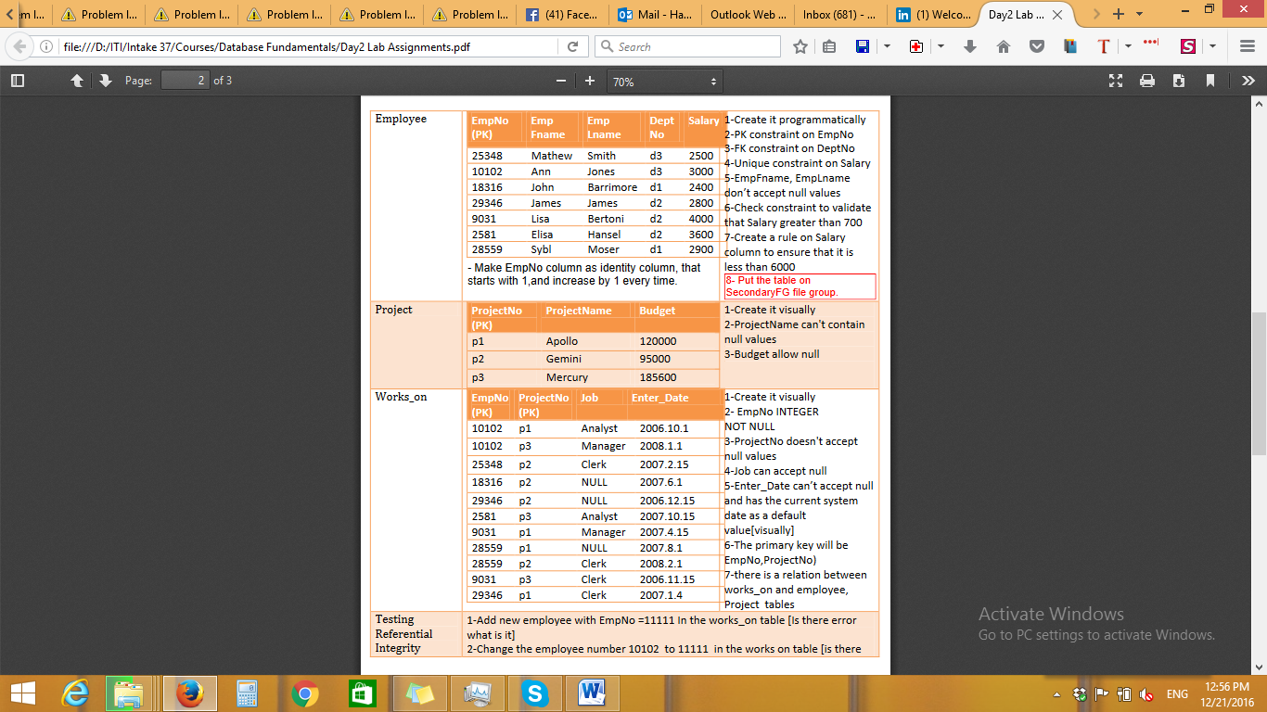
3. Modify the tables as following:
   1. Add TelephoneNumber column to the employee table
   2. drop this column
4. Delete the primary key of the Employee table. Why it will not work?
   1. Can a Primary key refer to Unique key instead of Foreign key?
5. Display the constraints for the Employee table using 2 different methods (Bonus)